1920’s Essential Knowledge Study Guide
Results of Improved Transportation
Brought about by Affordable Automobiles
• Greater mobility
• Creation of jobs (car making)
• Growth of transportation-related industries (road
construction, oil, steel, automobile)
• Movement to suburban areas

Use of the Assembly Line
• Henry Ford, automobile
• Rise of mechanization (replace human and animal
labor with machines)

Communication Changes
• Increased availability of telephones
• Development of the radio and broadcast industry
• Development of the movies

Ways Electrification Changed American life
• labor-saving products (e.g., washing machines, electric
stoves, water pumps)
• Electric lighting
• Entertainment (e.g., radio, movies)
• Improved communications (telephone, radio)

Prohibition
• Prohibition was imposed by a constitutional Amendment
(18th) that made it illegal to manufacture,
transport, and sell alcoholic beverages.
• Speakeasies were created as places for people to drink
alcoholic beverages.
• Bootleggers made and smuggled alcohol illegally and
promoted organized crime.
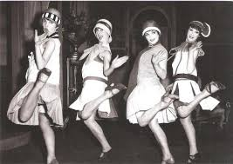
• Repealed by the 21st Amendment.
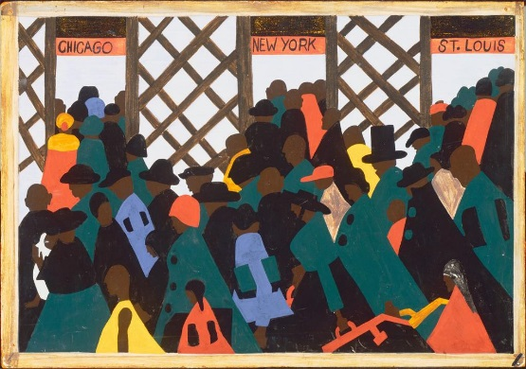
Great Migration North and West
• Jobs for African Americans in the South were scarce and
low paying.
• African Americans faced discrimination and violence in
the South.
• African Americans moved to cities in the North and
Midwest in search of better employment opportunities.
• African Americans also faced discrimination and
violence in the North and Midwest.

Social Changes
Cultural Climate of the 1920s and 1930s
• Art: Georgia O’Keeffe, an artist known for urban scenes
and, later, paintings of the Southwest
• Literature: F. Scott Fitzgerald, a novelist who wrote about
the Jazz Age of the 1920s; John Steinbeck, a novelist who
portrayed the strength of poor migrant workers during the
1920s – 1930s
• Music: Aaron Copland and George Gershwin, composers
who wrote uniquely American music

Harlem Renaissance
• African American artists, writers, and musicians based in
Harlem revealed the freshness and variety of African
American culture.
• Art: Jacob Lawrence, a painter who chronicled the
experiences of the Great Migration through art
• Literature: Langston Hughes, a poet who combined the
experiences of African and American cultural roots
• Music: Duke Ellington (piano) and Louis Armstrong
(horn), jazz musicians; Bessie Smith, a blues singer
• The popularity of these artists spread beyond
Harlem to the rest of society.
