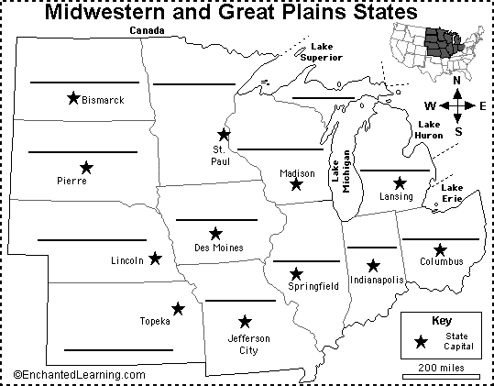
Midwest Region

Midwest Region
Illinois - IL
Indiana - IN
Iowa - IA
Kansas - KS
Michigan - MI
Missouri - MO
Minnesota - MN
Nebraska - NE
North Dakota - ND
Ohio - OH
South Dakota - SD
Wisconsin – WI

