Rocky Mountain Region
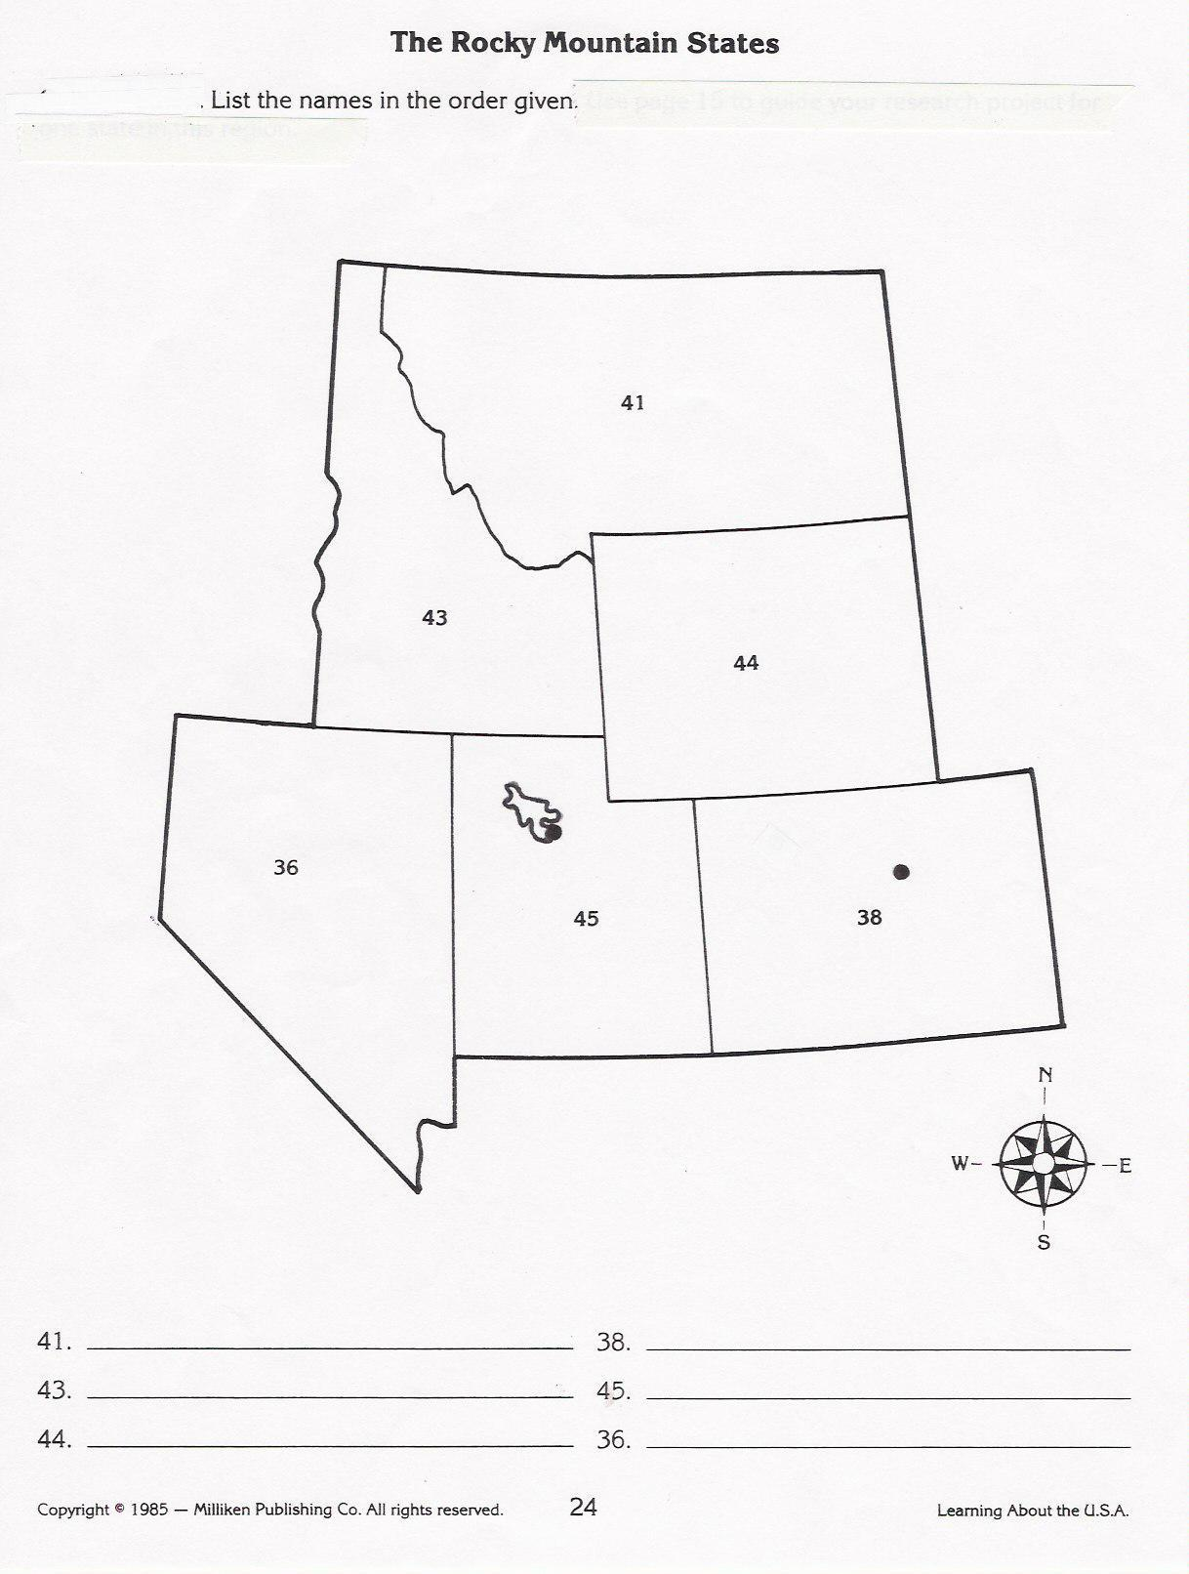
Rocky Mtn. Region
Colorado – CO
Idaho – ID
Montana – MT
Nevada – NV
Utah – UT
Wyoming – WY

