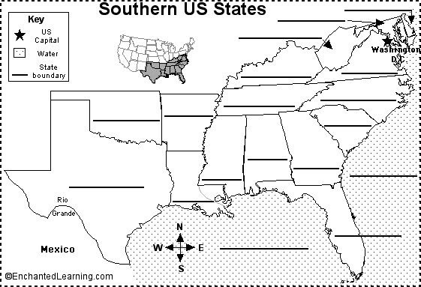
Southeast Region
Southeast Region
Alabama - AL
Arkansas - AR
Delaware - DE
Florida - FL
Georgia - GA
Kentucky - KY
Louisiana - LA
Maryland - MD
Mississippi - MS
North Carolina - NC
South Carolina - SC
Tennessee - TN
Virginia - VA
West Virginia- WV

