Name:___________________
Spanish American War US5ab Worksheet
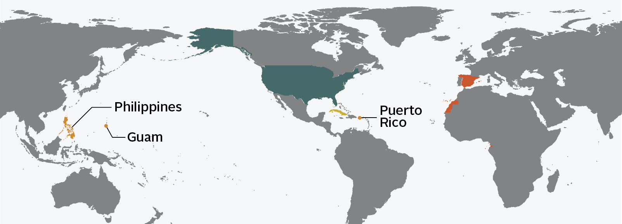
The Spanish American War, 1898
Cuba
Spain
1. Draw triangles around Spain and its allies.
2. Draw circles around the U.S. and its allies
3. Draw squares around the areas the U.S. gained as a result of the Spanish American War.
4. Draw a diamond where the fighting occurred during the Spanish American War.
5. What year did the Spanish American War occur?

6. The following are reasons for U.S. involvement in the Spanish American War. Please explain each reason in detail.
Yellow Journalism
Protect business interests in Cuba

Support Cuban rebels fight for independence
U.S.S. Maine

The following are the results of the Spanish American War. Fill-in-the-blank to make each sentence correct.
7. The _______________ ________________ emerged as a _______________ power. (Got ____________________ up)

8. _______________ gained independence from ___________________.

9. The U.S. gained possession of ___________, ______________ _________, and the __________________________.

10. Describe Roosevelt’s Big Stick Diplomacy.

