Technological Innovations during the early 1900’s Summary
It’s Electrifying!
A long time ago, American homes and streets were dark at night because there were no electric lights. Thomas Edison changed all that when he invented the first electric light bulb. For the first time Americans gained control over the light in their homes. Industrial plants could now operate continuously with shifts of workers coming in around the clock.

Before long, electricity would be used for mechanical purposes, also. Manufacturers began to produce small and large appliances for use in the home. Labor-saving devices like the washing machine, electric stove, and water pump helped people shorten the amount of time it took to do housework. Steam engines were replaced by electric motors and tools, making factories safer and boosting production and industrial growth.

Communication was improved with the invention of Alexander Graham Bell’s telephone. Entertainment changed with the development of radio, movies, and television—all powered by electricity!

Connecting the Country
“Watson, come here, I want you!” With those words, Alexander Graham Bell had successfully invented a machine so that people who were far apart could talk to one another. In 1876, Bell’s telephone did not stir up much interest. Most people thought of it as a toy. Bell formed the Bell Telephone Company in 1877. By 1885, he had sold more than 300,000 phones—mostly to businesses, helping to improve communication.

Radio is also one of our most important means of communication. No one person invented the radio. Instead, many people contributed to the development of radio. Today, radio stations around the world broadcast news and music continuously. The common use of radio is broadcasting. David Sarnoff was one of the first people to consider the entertainment possibilities of radio. As president of the Radio Corporation of America (RCA), Sarnoff built the company into a major radio and television manufacturer. RCA formed the National Broadcasting Company (NBC) in 1926. The rest is broadcast history. In the late 1800s, Thomas Edison and George Eastman helped to develop the first moving picture cameras. By the 1920s, the movie industry was well on its way. Millions of Americans went to the movies at least once a week. Radio, television, and the movies brought a common culture to the people of the United States. For the first time, people all across the country had access to the same programs.

The Affordable Automobile
No single person invented the automobile, but Henry Ford changed the way in which the automobile was produced. Ford wanted to build “a motor car for the multitudes”—one that almost anyone could afford. How did Ford succeed? He introduced the assembly line. On the assembly line, the Model T frames traveled slowly along a moving belt. Workers added parts as the cars passed by. This method cut the time needed to build a car. It also allowed for the mass production of cars. Mass production means making large numbers of a product quickly and cheaply. Because of mass production, Ford could sell his cars at a lower price than other auto makers could. At first, most people laughed at automobiles; however, attitudes soon changed. Americans realized that automobiles gave them greater mobility—they could travel to more places and move more quickly than ever before. Many people who lived in the city near their jobs wanted to escape the crowded conditions so they moved to the suburbs, the areas just outside the cities, and drove in to work each day.

Transportation-related industries such as road construction, oil, steel, and automobile grew. New jobs were created because of the invention of the affordable automobile. The first service stations were built around 1913. Motels sprung up to house motorists who ventured farther and farther away from home. Taxis and buses soon became common on city streets.

Winged Flight
In December of 1903, two brothers from Ohio, Orville and Wilbur Wright, became the first men to successfully fly an engine-powered flying machine. Although this first flight near Kitty Hawk, North Carolina, lasted only 12 seconds, it was the beginning of an aviation industry that within 25 years would transport thousands of Americans across the country and around the world.

Technological Innovations of the early 1900’s
1. Electricity provided much more than just lighting. Describe how electricity changed America

2. Create a title for the following chart:

Washing Machines
Water Pumps
Electric Stoves

3. Cause: Electricity allows steam engines to be replaced by electric motors.
Result:

4. Cause: Electricity leads to new forms of entertainment such as radio, movies and television.
Result:

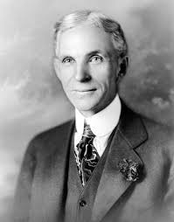 | 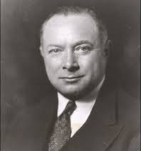 | 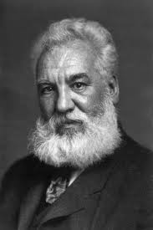 | 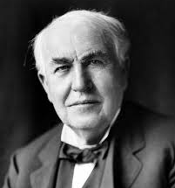
Henry Ford | David Sarnoff | Alexander G. Bell | Thomas Edison | The Wright Brothers
5. Match the correct industry or invention with each person.

6. Explain how an assembly line works and how it was better than the old method of building cars.

7. Cause: Assembly lines make automobiles affordable.
Result:

8. Who were the first men to successfully fly an engine powered flying machine? What year did it happen and where did it occur?

