Name:_____________________
Technology Advances in the late 1800’s and early 1900’s
1. Complete the following chart.
Automobiles Become Affordable

2. Complete the following chart.

3.
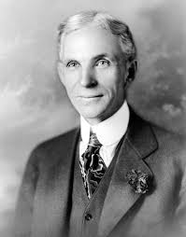 | 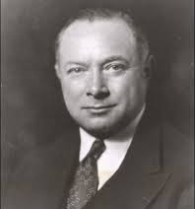 | 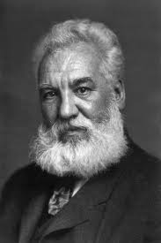 | 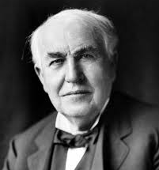
Henry Ford | David Sarnoff | Alexander G. Bell | Thomas Edison | The Wright Brothers

4. ______________________ extended progress into all areas of American life, including neglected ____________ areas.

5. Which technology/invention from this time period do you believe is most influential in our lives today?

Improved entertainment such as
_____________, _______________ and
__________, increase the quality of
____________.
People now have more free time because these devices decrease time spent working. With more free time people now need
____________________________
Three of the major devices were:
______________ _______________

______________ _______________

______________ _______________

__________________________
allowed for the creation of __________________________ devices

