The Cold War (1945-1991) Summary

The Cold War was a state of tension between two superpowers, the United States and the Soviet Union, without the two ever directly fighting each other. The two countries were very different. The Soviet Union was Communist and the United States was democratic, the Soviet Union had a dictator and the United States votes for leaders, the citizens of the Soviet Union had few freedoms, the citizens of the United States had many. The world was divided between countries that either supported the capitalist, democratic United States or the communist Soviet Union. The U.S. formed an alliance called the North Atlantic Treaty Organization (NATO). The Soviet Union formed an alliance called the Warsaw Pact.

The Soviet Union controlled Eastern Europe after WWII. President Truman decided the goal of the United States would be containment, meaning to not allow any new communist countries. This led to the first conflict of the Cold War, the blockade of West Berlin by Joseph Stalin. Truman ordered supplies be flown into West Berlin to keep it alive and in control by the democracies. The second crisis occurred in 1950 when communist North Korea tried to take over anti-communist South Korea. The United States joined a United Nations force to stop North Korea and the Chinese communists but the conflict ended in a stalemate (tie) in 1953.

The U.S. came close to nuclear war during the Cuban Missile Crisis when they discovered that the Soviet Union was placing nuclear missiles in Cuba. A Cuba revolt had just overthrown the established Government in Cuba. The new leader of Cuba, Fidel Castro, decided Cuba would be communist. Now communism had reached Cuba, just 90 miles from the United States! Cuba and the Soviet Union reached an agreement to place missiles in Cuba. America was worried the Soviet Union and Cuba could attack the U.S. by launching missiles at America. The U.S. Navy blockaded Cuba, saying America did not want Cuba to gain any more missiles. For two weeks in October 1962, the world braced waiting for a nuclear war to begin between the U.S. and Soviet Union. The U.S. President, John F. Kennedy, helped negotiate a deal with the Soviets to end the standoff. The U.S. would remove missiles from Turkey, which was located beside the Soviet Union, and the Soviets would remove their missiles from Cuba. Direct fighting between the superpowers was avoided.

Some people in the United Sates believed in the domino theory. This meant that if one country became communist, the country next to it would as well. In 1965 the U.S. sent troops to South Vietnam to stop it from becoming communist. At first most Americans supported the war because they feared communism and did not want it to spread. After 1968 however, people started to believe the war could not be won. The war in Vietnam was very controversial and eventually the U.S. agreed to a cease-fire in 1973. Many soldiers returning home from the war were greeted with jeers and insults. In previous wars, Americans could justify the costs by pointing to the gains made by the war. In the Vietnam War nothing of value was gained for America. Communist North Vietnam then took over South Vietnam in 1975.

By the late 1980s the Soviet Union’s economy was beginning to fall apart. Many countries in the Soviet Union wanted independence. In 1989 the Berlin Wall was taken down and Germany became one country again. By 1991 all countries left the Soviet Union and the Cold War was over.
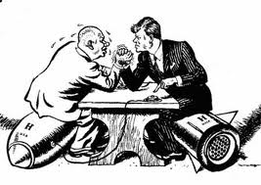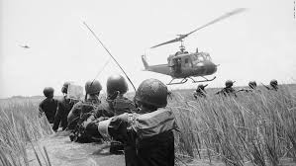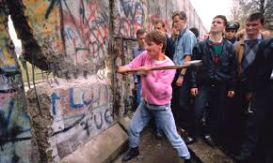
The Cold War Summary Questions Name:_____________________
1. What was the Cold War?

2. Complete the chart:
The Superpowers

Country
Government System
Do citizens enjoy many freedoms?
Military Alliance

3. Complete the chart:
Term | Definition | Draw a Picture
Containment
Domino Theory

4. Place the following events in chronological order by numbering 1-4 in the space provided.
The Berlin Wall falls and the Soviet Union breaks up  ____ | Cuban Missile Crisis  ____ | The Korean War  ____ | The Vietnam War  ____

5. How was the Vietnam War different from previous American Wars?

6. When and why did the Cold War end?

