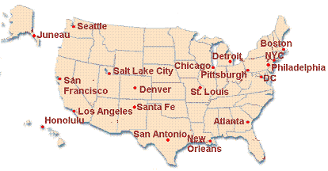
Cities serve as centers of trade and have historically had political, economic, and cultural significance to the development of the United States.
List each city under the correct region.
Northeast
1.

2.

3.

4.
Southeast
1.

2.

3.
Southwest

1.

2.
Pacific
1.

2.

3.
Non-Contiguous
1.

2.

Midwest
1.

2.

3.
Rocky Mountain
1.

2.

