World War I (1914-1918) Essential Knowledge Study Guide

Causes of WWI (MAIN)
• Militarism
• Alliances
• Imperialism
• Nationalism
- The spark that set off all the tensions was the assassination of
the Austria-Hungary Archduke Franz Ferdinand by the
Serbian terrorist Gavrilo Princip

Reasons for United States involvement in World War I
• Inability to remain neutral
• German submarine warfare: Sinking of the Lusitania
• United States economic and political ties to Great Britain
• The Zimmermann Telegram

Major Allied Powers Central Powers
- Great Britain - Germany
- France - Austria-Hungary
- Russia - Bulgaria
- Serbia - Ottoman Empire
- Belgium
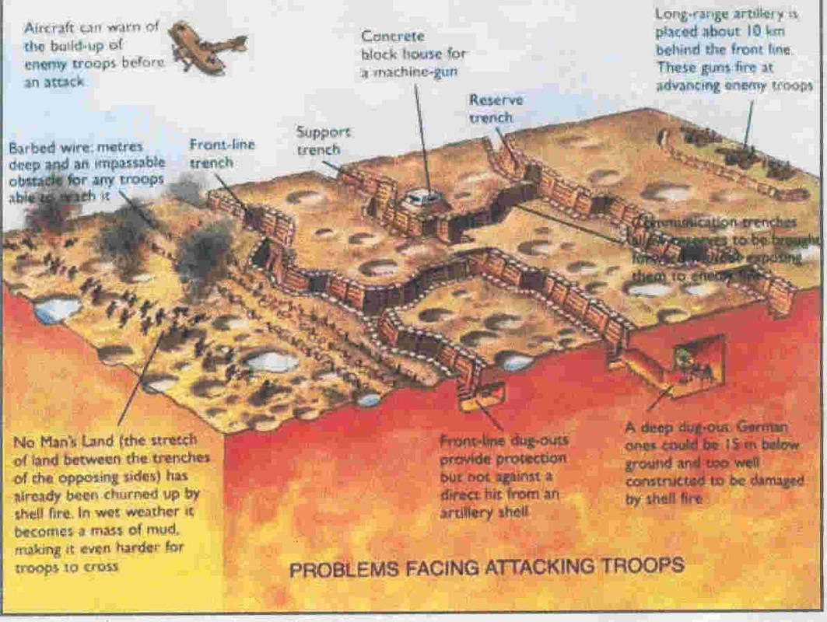
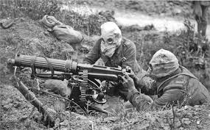
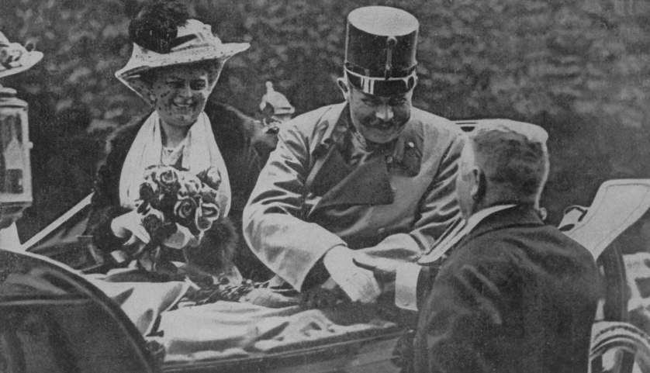
- United States (1917)

Warfare Technology
• WWI is often referred to as the first modern war
• Trench warfare made the war deadly and drawn out
• Several new weapons made the war especially deadly:
- Airplanes - Tanks - Machine Guns
- Submarines - Poison Gas

United States Leadership as the War Ended
• At the end of World War I, President
Woodrow Wilson prepared a peace plan
known as the Fourteen Points that called
for the formation of the League of Nations, a
peacekeeping organization.
• The United States decided not to join the
League of Nations because the United
States Senate failed to ratify the Treaty of Versailles.
• The Treaty of Versailles severely punished Germany:
- Germany had to accept blame for the war
- Germany had to pay war reparations
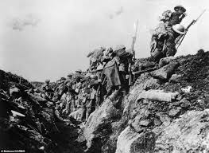
- Germany had to decrease the size of its military

